Cumbria Office of the Police, Fire and Crime Commissioner

HAY JOB PROFILE

Job Title: Estate Trade Supervisor
Salary Scale: Scale 6
Department: OPFCC Estates
Reports To: Estates Maintenance Officer
Location: Estate wide

All employees must ensure compliance with the OPFCC Health and Safety Policy, and all other relevant statutory Health and Safety Legislation.
This job profile has been written primarily for evaluation purposes and may not detail some less major duties allocated to the postholder, nor cover duties of a similar nature, commensurate with the grade, which may from time to time be reasonably required by the relevant manager.

This is a politically restricted post and reference should be made to the Office of the Police, Fire and Crime Commissioner’s politically restricted post policy.

JOB PURPOSE
  - Manage a team of Skilled and Semi-Skilled Estates Operatives to deliver maintenance and support services to the OPFCC Estate.
  - Work with other members of the team to deliver building maintenance and building work programs to the Commissioners Estate acting as part of the team serving our customers to maintain their facilities

PRINCIPAL ACCOUNTABILITIES
  - Management of the Estates trade team including developing and setting programs of work, mentoring and supporting, undertake annual performance reviews, undertake regular one to one meetings, and maintain accurate records of time keeping. Set clear objectives and monitor progress against these, advising the maintenance officer of trends and performance.
  - Work closely with the Estates Administrator and Estates Maintenance Officer to monitor and action jobs, review progress, take action to rectify works not undertaken of requests made via the Estates Helpdesk.
  - Co-ordinating technical and compliance training requirements for the team, including identifying training gaps and organising appropriate courses to close the gaps
  - Proactively liaise and manage contractors to ensure they are delivering work which best suits the objectives of the department ensuring adequate quality of work and provide feedback to the maintenance officer
  - Liaise with property managers and operational officers to arrange for the safe collection and / or destruction and disposal of property.
  - Support the estate engineer to undertake monthly generator testing to ensuring sound operation of the equipment and accurate record keeping of findings.
  - Supervise and monitor changing of door codes and other security related works carried out by contractors or Estates and Feet Operatives.
  - Manage and monitor Estates Winter Maintenance in line with the policy to minimise disruption to operational policing force wide.
  - manage the annual inspection of ladders, first aid kits and ensure fire- fighting equipment is maintained in the correct locations. Keep and maintain accurate records to demonstrate compliance.
  - Manage the in-house PPM regime including testing of fire alarm, inspection of emergency lights, legionella flushing ensuring accurate records are kept and defects reported for rectification.
  - Maintain accurate information on the Estates Asset Management System related to the department’s functions.
  - Such other duties at a comparable level of responsibility relating to the work of the department as may be required.

DIMENSIONS
The post holder will be responsible for:-

Managing and setting work duties for a team of Estates Semi-skilled / skilled operatives (currently five).

Being part of a maintenance team which delivers activities which directly support operational activities.

Be the department lead on property destruction and disposal.

Be a member of the Estates Call-out team.

There will be a requirement for flexibility to travel and work around the force area

KEY FEATURES

4.1 Framework and Boundaries
The postholder will be required to know, and work to:

- Control of Asbestos Regulations 2012
- Approved Code of Practice for ‘The control of legionella bacteria in water systems’
- Construction Design Management Regulation 2017
- All current H & S legislation in respect to this post

4.2 Important Working Relationships
Internal

- Estates staff
- All colleagues with police and fire.

External

- Suppliers and Contractors

4.3 Major Challenges
Ongoing maintenance of the estate is essential in supporting operational activities.

4.4 Knowledge and Skills
- Understanding and knowledge of the management of building maintenance
- Adaptable, resilient and the ability to think creatively to solve problems
- Awareness of general estate management
- Previous experience of managing a direct labour works team within a large organisation, preferably public sector with a large estate of properties and various types and ages
- Awareness of the importance to provide customer focus service.
- Computer literate
- Good communication and team working skills
- Self- motivated, diplomatic and assertive.
- Driving licence essential
- Awareness of confidentiality.
- Flexibility to respond to changes in workload and nature.

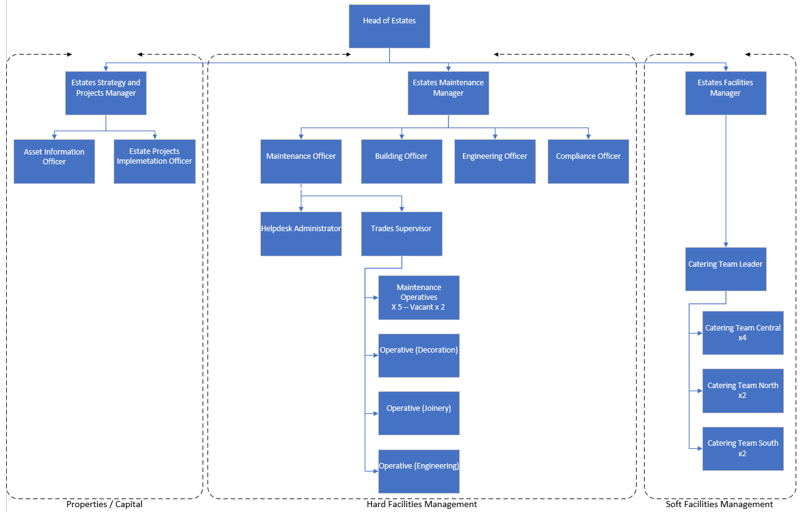
- ORGANISATION CHART

Cle

OFFICE OF THE POLICE, FIRE AND CRIME COMMISSIONER
PERSON SPECIFICATION

JOB: Estate and Fleet Trade Supervisor

LOCATION: HQ

POST No:

 | ESSENTIAL | DESIRABLE
Experience  and  Knowledge  Skills & competencies required.  Eg Geographical knowledge of the area, familiarity with certain legislation. | Management and supervisory experience of a direct labour trades team  Good understanding breakdown maintenance and the role it plays in wider estate management | Evidence of driving improvements in the efficiency of in-house direct labour.
Education  and  Training  General education  Specialist training | Relevant technical qualification or demonstrable experience in a technical building qualification equivalent to NVQ Level 4.  Relevant experience in similar role performing maintenance  Legionella knowledge and awareness | Work experience in public sector or similar large organisation  Willingness to develop and undertake further training
Special Aptitudes and  Intelligence  Does the job involve any special dexterity? – Manual, verbal skills | Practical skills and knowledge of building and engineering processes  Clear understanding of the requirements of the post-holder’s responsibility for managing H&S
Desired Character Traits  Personal qualities that relate to job. Eg: Punctuality, reliability, self-motivation, concentration. | Strong organisational skills  Ability to influence and communicate with others  Ability and willingness to challenge and make positive recommendations in respect of building maintenance  Team player  Flexibility to respond to changes in workload and nature.  Trustworthiness in respect of managing sensitive information. | Enthusiastic for delivering work of a high quality
Circumstances  Eg: Driving licence/mobility  Shift working  Unusual/irregular working hours | Driving license.  Availability to travel throughout the force area.

