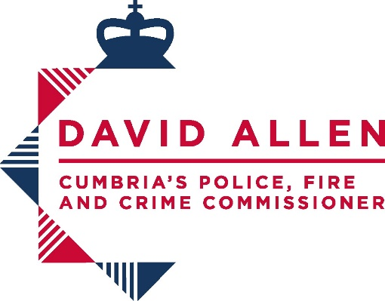

Cumbria’s Office of the Police, Fire & Crime Commissioner
HMICFRS Responses

Cumbria Police Fire and Crime Commissioner (PFCC) response to inspections of Cumbria Constabulary published by Her Majesty’s Inspectorate of Constabulary and Fire and Rescue Services (HMICFRS)

Section 33 of the Police Act 1996 (as amended by section 37 of the Policing and Crime Act 2017) requires local policing bodies to respond to recommendations in inspectors reports within 56 days.
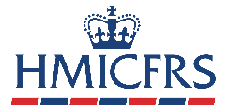

Inspection Title: | State of Policing: The Annual Assessment of Policing in England and Wales 2023
Date Published: | 19/07/2024
Type of Inspection: | Annual Assessment Report
Key Findings
This is His Majesty’s Chief Inspector of Constabulary’s second report to the Secretary of State, under section 54(4A) of the Police Act 1996. It contains his independent assessment of the efficiency and effectiveness of policing in England and Wales. It is based on the inspections we carried out between 1 April 2023 and 31 March 2024.
This report draws on findings from inspections of police forces in England and Wales, to provide an overall view of the state of policing.

Link to the report:
State of Policing: The Annual Assessment of Policing in England and Wales 2023

PFCC & Constabulary Response to Report and Recommendation:
Cumbria’s Police, Fire and Crime Commissioner, David Allen, said: “I fully welcome this report by His Majesty’s Chief Inspector of Constabulary as he highlights some fundamental points that need to be addressed.

“Here in Cumbria, we want to continue to build on the trust between the Police and the community – if our residents don’t trust the Police to do their job around prevention and reduction of crime and protection of victims then we have failed. It is my remit, along with the new Government to increase trust and confidence in the criminal justice system and I intend to play my part in ensuring this happens. We have a good police force in Cumbria and one that is continuously improving, but there is always room to be better and to ensure that public service is at the heart of what we do and deliver.

“I have already raised concerns with our new Home Secretary, Yvette Cooper, around financial support and violence against women and girls as I am keen to ensure the best for the Police Service of Cumbria and its residents. I look forward to working with the Home Office and the Chief Constable to address the recommendations made by Andy Cooke in his report.

“We’ll never have too many Police Officers on our streets, but I am dedicated to ensuring that the public see more visibility and that the workload is balanced and that we have the right resource in the right place at the right time. However, I am also determined that the Officers on our streets have the appropriate training and experience they need to keep the public and themselves safe and manage situations appropriately. Operation Uplift gave us a wave of new recruits that I am sure are keen to do the job to the best of their abilities, but they need the correct support and training to do so.

“I want to assure the public that Cumbria Constabulary are continuously aiming to improve their service and my role is to hold the Chief Officer to account on behalf of the public to ensure that this is achieved. In my short time in post, I see a good force striving to be the best that it can. By working with the force, challenging, and holding it to account and seeking the best for the force from the government I will help and assist with this.

“I would ask that a cautious and considered approach is taken about any changes to the national funding formula. Cumbria along with several other forces benefits financially from the existing formula and any movement has potential significantly and adversely impact on the policing service in our county.”

