OFFICE OF THE POLICE, FIRE AND CRIME COMMISSIONER

HAY JOB PROFILE

Job Title: Estates Maintenance Operative Department: Estates & Facilities

Reports To: Estates Trades Supervisor Location: Countywide

All employees must ensure compliance with the Cumbria Constabulary Health and Safety Policy, and all other relevant statutory Health and Safety legislation.
This job profile has been written primarily for evaluation purposes and may not detail some less major duties allocated to the postholder, nor cover duties of a similar nature, commensurate with the grade, which may from time to time be reasonably required by the relevant manager.

1. JOB PURPOSE

As a Maintenance Operative you will be a crucial part of our Estates team, responsible for a wide range of maintenance tasks across the Police and Fire Crime Commissioner (PFCC) estate across Cumbria. Your role will involve both planned and reactive maintenance, ensuring our facilities are safe, functional and fully compliant for all users.

- PRINCIPAL ACCOUNTABILITIES

  - To carry out maintenance and minor works as instructed by the Estates Trade Supervisor, including, but not restricted to, the replacement of fluorescent tubes, minor carpentry and plumbing works, and flushing of water outlets.

  - To provide reports to the Estates & Facilities team of defects and assisting the team in the use of external contractors, including escorting contractors.

  - Removal of confidential waste and old uniform to central locations.

  - Assist with the transportation and disposal of seized, lost & stolen property.

  - Support technical estates staff with generator testing and maintenance where required.

  - Change door codes and other security related works as required.

  - Undertake Health & Safety inspections of ladders, first aid kits and ensure fire- fighting equipment is maintained in the correct locations. Weekly fire alarm test, weekly inspection of lights and alarms.

  - Undertake a programme of planned preventative maintenance works as instructed by your line manager reporting any defects as and when they are discovered.

  - To complete the necessary paperwork to maintain a detailed audit trail of jobs completed and costs incurred.

  - Carry out other duties as required, including removing of recycling material, moving of office equipment and furniture, setting out of conference rooms etc.

  - Carry out winter maintenance works to footpaths & parking areas.

  - Undertake Legionella testing, cleaning and recording where required

  - To be responsible for the provided work vehicle and ensuring the vehicle is always secure, kept in a clean & roadworthy condition, reporting any issues as required.

  - To be competent in use of IT equipment to maintain a detailed audit trail of jobs completed.

  - To carry out any other duties, in line with grade, directed by appropriate line manager.

3. DIMENSIONS

3.1 The post holder will be responsible for undertaking work under direction of the estate’s trades supervisor.

4. KEY FEATURES

4.1 Framework and Boundaries

The postholder will be required to know, and work to:
- PFCC policies on Equal Opportunities, Health & Safety, Data Protection. Also to comply with the requirements of the Human Rights Act 1998 and with all Force guidance documents and relevant protocols.
- You will be required to pass satisfactory vetting clearances
- To maintain confidentiality and observe data protection and associated guidelines where appropriate.

4.2 Important Working Relationships

External: Contractors and external trade suppliers.

Internal: Estates & Facilities team staff and all staff as required.

- ORGANISATION CHART

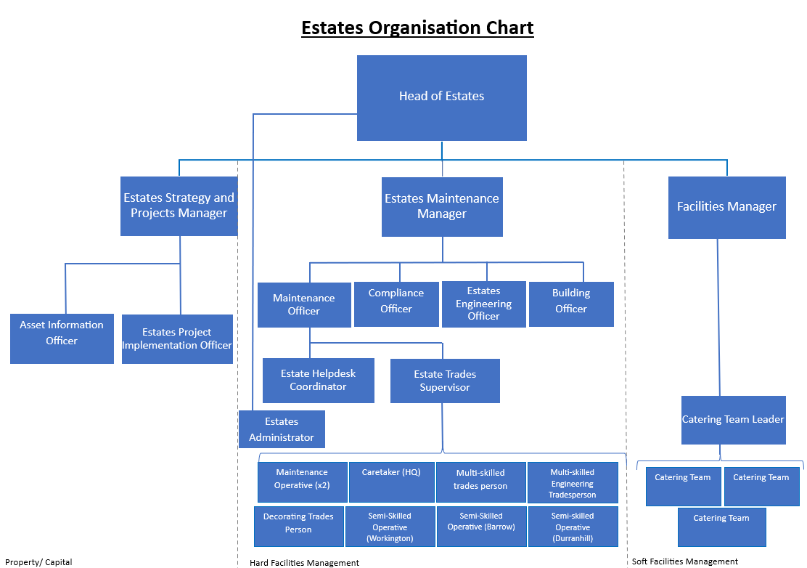

Agreed by Post Holder: Date:

Line Manager: Date:

Head of Department/
Division: Date:

OFFICE OF THE POLICE FIRE AND CRIME COMMISSIONER
PERSON SPECIFICATION

JOB: Maintenance Operative POST No:

LOCATION: Countywide

 | Essential | Desirable
Experience  And  Knowledge  Skills & competencies required.  Eg Geographical knowledge of the area, familiarity with certain legislation. | Provide evidence of experience.  and undertaking practical work of a similar nature. | Good basic understanding of computers including outlook electronic diary  Trade qualification in plumbing/Joinery
Education  And  Training  General education  Specialist training | Manual handling awareness  Health and safety awareness  Willingness to learn new skills | Training & experience in PAT Testing and ladder inspections  Legionnella knowledge and awareness  Asbestos awareness  Working at heights training
Competency and Values Framework | CVF Level 1
Circumstances  Eg: Driving licence/mobility  Shift working  Unusual/irregular working hours  Standby/callout | Must hold a full driving licence.  Availability to travel throughout the force area.

